**Do while loop**

JavaScript do while loop is an **exit** control loop which means the statements executed first then the condition checked in the end of the loop.

Browser executes the statements in a do while loop at least once time. And then repeatedly executes the statements in a do while loop as long as the given conditional expression is true.

**Syntax:**

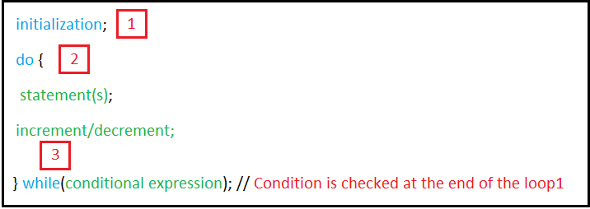

**How do while loop keyword works?**

From the previous syntax we can see that do while loop keyword consists of 3 parts:

Part 1: Initialization / starting point

Part 2: do keyword.

* Statements
* Mathematical equation (i.e. ++ or --).

Part 3: while keyword

We will use imaginary arrow to show us the path of execution the code:

The path of this arrow is shown in this picture:

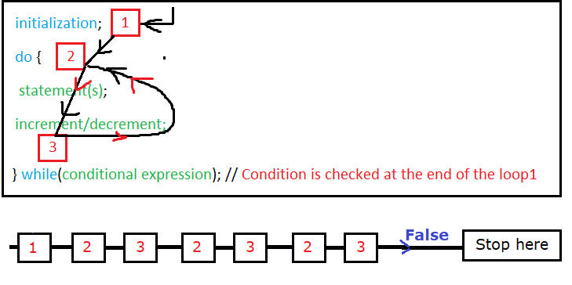

The arrow moves from 1 to 2 to 3 then returns to 2 again then transfers to 3 then to 2 again……

Because the condition expression is true the arrow will follow this path until the expression condition will be false then **exit** do while keyword and go to execute the next down statements.

**Note**:

1. Arrow passes to number1 only one time (when **entering** the do keyword)
2. Loop path is expressed on numbers 2 and 3.
3. What you do with do while loop can do with while loop as while and do while loop is very similar with slight differences.
4. You can convert while to do while and the verse as their syntax is very similar.

**Example1:**

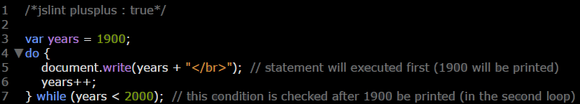

**Example2:**

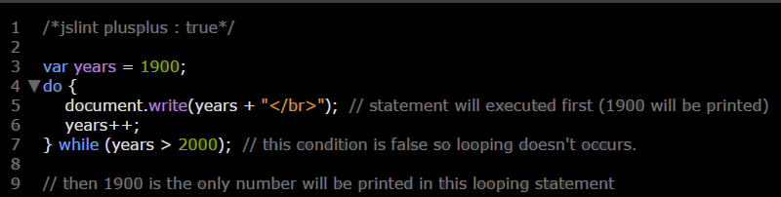

**Example3:**

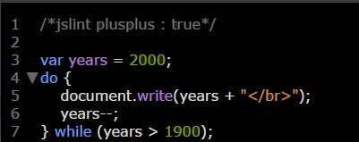

**Example4:**

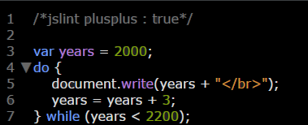

**Example5:**

